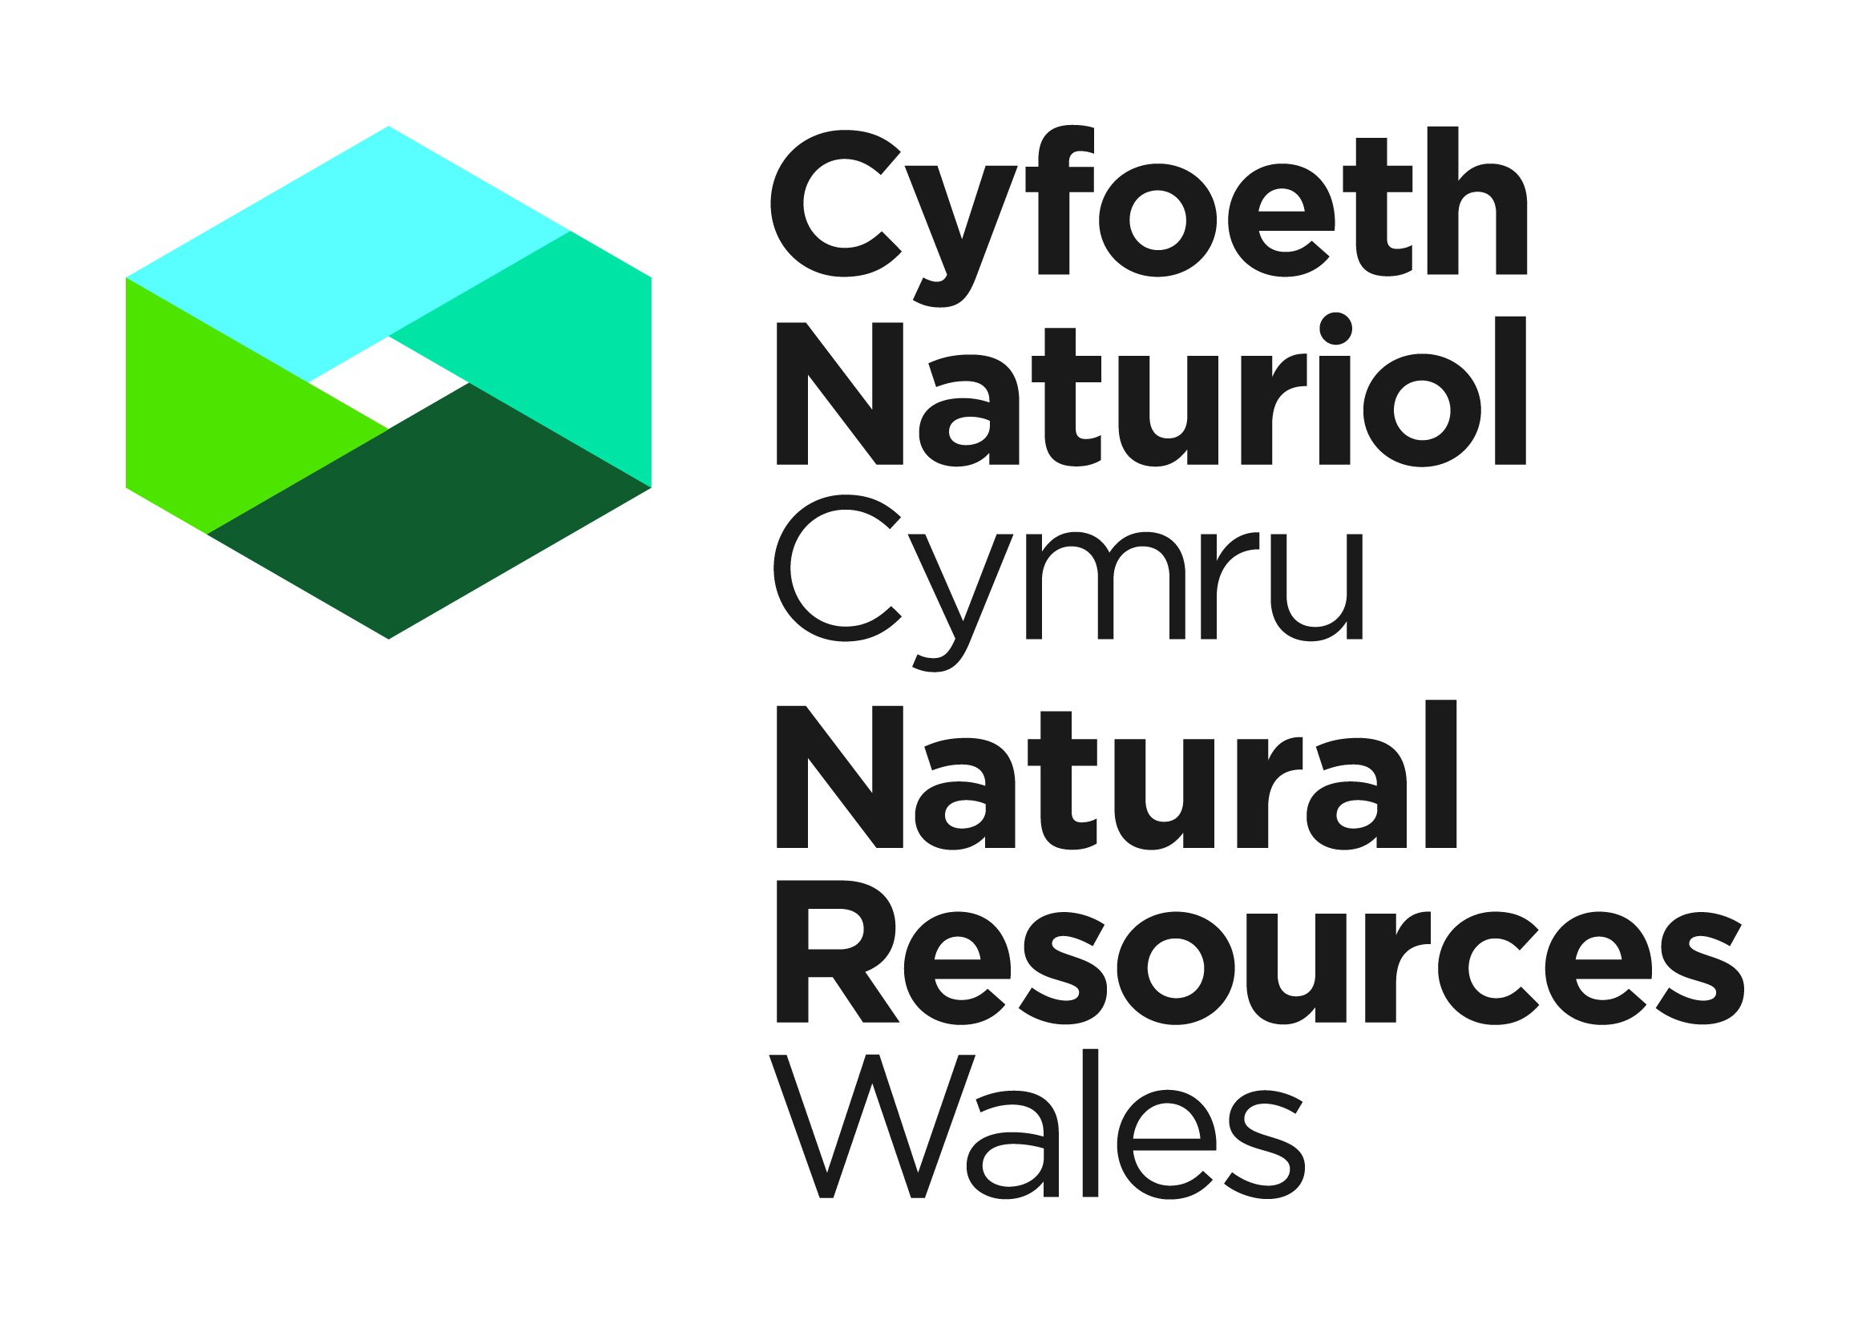

Bird scientific, research, educational and photography: Application for a licence to disturb, take or possess wild birds or their eggs for:

- Scientific, educational and conservation purposes;
- Ringing or marking;
- Examining any ring or mark;
- Photographic purposes.

NOTES FOR GUIDANCE
Please read the following notes carefully.

a. | This is an application form for wild birds, including those listed on Schedule 1 of the Wildlife and Countryside Act 1981(as amended), at or near the nest in order to monitor breeding success, protect nests or undertake scientific studies. Licences can be granted allowing people to carry out activities, which would otherwise be illegal. Applicants must be able to demonstrate that they have a suitable amount of expertise to achieve the objectives of the proposed work.
b. | All applications to disturb Schedule 1 birds for the purpose of ringing or other marking, or to take part in the Nest Record Scheme, must be made to the British Trust for Ornithology (BTO). The BTO assesses these applications and recommends whether a licence should be issued.
c. | All questions in this application form must be completed unless otherwise stated: failure to provide adequate information will delay the processing of your application. Any further information you wish to provide should be appended on additional sheets. We aim to process applications within 30 working days of receipt of all the information requested. We cannot guarantee an earlier response.
d. | It is a condition of any licence issued that a report of the work carried out under licence is submitted within four weeks of the expiry of the licence. The Licence Report Form can be found on our website. Failure to do so may constitute an offence. Information from these reports is required to provide summary information to NRW and others on the number of licences issued the purpose of the licence and which species are covered. None of these summary statistics includes personal information about licensees. The information may also be used for conservation purposes and shared with other organisations.
e. | Applications are dealt with chronologically. This means they are processed according to when they were submitted. Please submit your application in good time. If you think your application needs to be dealt with urgently, please ring us to discuss and agree this before its submission.
f. | All questions in this application form must be completed unless otherwise stated: failure to provide adequate information will delay the processing of your application. Any further information you wish to provide should be appended on additional sheets. We aim to process applications within our service level agreements of receipt of all the information requested. We cannot guarantee an earlier response.
g. | Natural Resources Wales can modify or revoke any licence issued. Any licence issued will be revoked immediately if it is discovered that false information has been provided which resulted in the issue of a licence.
h. | Amendment or renewal of a licence may be requested by completing the relevant forms on the NRW website.
i. | The information provided by you will be processed by Natural Resources Wales under the General Data Protection Regulation. This will enable us to process your application; to monitor compliance with any permit conditions and to process renewals.  We will use the information you provide in connection with the following:  - Consultation with third parties who are relevant and responsible for responding to consultation requests from NRW to enable us to process your application

- Carrying out statistical analysis, research and development on environmental issues
- Preventing and investigating possible breaches of environmental law and taking any resulting action

Responding to requests for information under the Freedom of Information Act 2000 and the Environmental Information Regulations 2004
Note that the above is not an exhaustive list and NRW may use the data provided in connection with the application in other ways, as considered appropriate

We would also like to send you details about other topics we think may be of interest to you such as NRW news; services relating to environmental matters; asking for your feedback on our service; and more useful information.

If you consent to receiving further information from us, please tick the following box to confirm
Yes, I would like to receive additional information from NRW relating to environmental matters □
Please note we may pass the information on to our agents or representatives to carry this out for us

If you have any further queries or concerns, please contact dataprotection@naturalresourceswales.gov.uk. For further information on the processing of your personal details please see our Privacy Notice page

j. | This application form does not cover bird control. Applicants wishing to control wild birds must complete application form AFB01 which can be found on our website www.naturalresources.wales .
k. | Charges  - You must pay a fee for a licence unless you are exempt  - Charges are only applicable when there is a clear commercial benefit to the applicant, such as where a survey licence is sought to enable someone to operate commercially, or where a research project is proposed for commercial reasons  - For information on our charges and how to pay please click here
Information for completing an application form
1. | If the document is handwritten please complete in BLOCK CAPITALS
2. | Please answer ALL questions. Incomplete answers will mean delays in your application  being processed.
3. | Applications can be accepted either electronically or by post (electronic is our preferred option).  Electronic Applications  E-mail Applications to: specieslicence@naturalresourceswales.gov.uk. Please DO NOT also send the application by post. When sending in electronic applications, please ensure that all documents are clearly named.  Postal Applications  The application form must be signed by the proposed Lead Licensee. Please post to: Species Permitting Team, Natural Resources Wales, Maes y Ffynnon, Penrhosgarnedd, Bangor, Gwynedd, LL57 2DW
4. | We will aim to send an acknowledgement of receipt of your application within 5 working days.
5. | NRW aims to determine applications within our service level agreements from date of receipt of a completed application form and the required associated information. Please refer to the check list at the end of this form for further guidance. If we require further information from you during the determination period, for whatever reason, this will delay the determination period. Our service level agreements can be found at:  https://naturalresources.wales/permits-and-permissions/species-licensing/our-service-level-agreements/?lang=en
6. | All correspondence sent to you from NRW will be via e-mail. If an e-mail address has not been provided, we will contact you in writing through the post. Please note that postal correspondence may delay your application due to postal delivery times.

PART A: Proposed Lead Licensee Details

This section applies to the person who will be the ‘Lead Licensee’. This must be a named individual; company information is to be provided in 1c. As the Lead Licensee you will be responsible for ensuring compliance with the licence and all licence conditions. Please provide your full name, not initials.

1a. Proposed Lead Licensee details

Title | Forename(s) |  | Surname
Address
Town
County
Postcode
Primary Contact Number
Secondary Contact Number
E-mail address

1b. Organisation/Business Details
Address
Town
County
Postcode
Primary Contact Number
Secondary Contact Number
E-mail address

This licence is required for: | Personal | ☐ | Business | ☐ | Both | ☐

2. Who will provide the species expertise during the licensed work?
Lead Licensee ☐ Other ☐

If ‘other’, please provide following details:
N Name
E E-mail Address
T Telephone Number
Address

3a. Experience and Qualifications – this section relates to the person who is providing the expertise, as detailed in section 2.

Please give details of qualifications and/or experience in relation to working with the requested species. Please include details of any courses attended and submit copies of any relevant training certificates and completed log books to support the application.

b. References

Please provide two references from ecologists/ornithologists/relevant specialists who are familiar with your work. They must be able to comment on your experience of working with the relevant species and your ability to use the methods and equipment you have proposed within your licence application. Your referees must have held the appropriate species licence within the last two years and must have experience of your work for at least one survey season. Please note that we can only accept one reference from the company you currently work for.

All references need to be completed on the reference form and must be able to confirm the following:

- Their knowledge of the extent of the applicant’s experience in this type of work, including the use of any equipment

- Any knowledge they may have of the care taken by the applicant while engaged in this type of work, to avoid undue harm or disturbance to wildlife

- Their own experience in this field.

- The number of years they have known and worked with the applicant

c. Do you hold a similar level of licence from Natural England or Nature Scot for this species? If yes, please submit a copy of this/these licences with your completed application form. This information will be used to support the information supplied in this application in relation to your experience. Please note that this will support your application but does not automatically guarantee you will be granted with a licence by NRW.

Yes ☐ No ☐

4. Licensed Accredited Agents and Licensed Assistants

A Licensed Accredited Agent is a suitably qualified experienced person who is able to carry out work under a licence without the personal supervision of the Lead Licensee. If you propose to employ accredited agents please state what work they will be carrying out and their relevant experience. Please give their full names and addresses.

A Licensed Assistant is employed by a Lead Licensee or their Licensed Accredited Agent to work under their direct personal supervision at all times. Licensed Assistants do not need to be named on the application form/licence. However, the Lead Licensee should keep a log of all Licensed Assistants who have worked under a particular licence, as they may be asked to provide details at a later date.

a. If you propose to employ Licensed Accredited Agents please provide their details below

Name | Postal Address | E mail Address | Telephone Number

5. Designated Sites

Designated areas: Local Nature Reserves (LNR), National Nature Reserves (NNR), Sites of Special Scientific Interest (SSSI), Special Protection Area (SPA), Special Areas of Conservation (SAC), Ramsar sites.
a. | Will any part of the proposed activity fall within or adjacent to an area covered by a designated site? | Yes  ☐ | No  ☐
a. | Name of site(s):
c. | If the answer to the above is YES, have you consulted with Natural Resources Wales for advice on the implications of your application on the protected site? | Yes  ☐ |  |  | No  ☐
d. | Please provide the name of your contact in NRW and either the outcome of your consultations or the reason why you have not consulted. Please enclose any relevant correspondence:
e. | If the answer to 5a is yes: If you are a ‘competent authority’ under regulation 7 of the Conservation of Habitats and Species Regulations 2017, or if your plan or project has been subject to any consent, permission or authorisation from such a competent authority, please provide a copy of any relevant Habitats Regulations Assessment (HRA) carried out under regulation 63. | Yes ☐ |  | No ☐

PART B: Application Details

6. Please complete the table below to show all licensable actions that your project will involve. Please read the notes following this page to assist you in filling out the table correctly.

Species | Activity (1) | Number of birds | Method or field technique (2) | Time period in which the activity will be carried out (3) | Location (4) | Additional information (5)

NOTES

1. | Activity. List all the activities you wish to carry out. Start a new line if it helps to distinguish between different activities at different places. Choose from:  A. Disturb, through close observation– excludes any handling or physical examination of the nest, bird, eggs or derivatives. Please use additional information (5) for any further details of your proposed activities.  B. Take wild birds or wild birds eggs - Including handling for a limited period before release/replacement at their site of capture (e.g. weighing, taking measurements etc). Please use additional information (5) for any further details of your proposed activities. Please note that this application form does not cover bird control. If you wish to take wild birds or eggs as a method of bird control, please complete form AFB01.  C. Possess and control wild birds - If it is to be retained away from the site of capture. Please state in additional information (5) the address at which the birds would be kept, what conditions they would be kept under, the reason for their retention and the method and site of release. Continue on a separate sheet if necessary.  D. Possess and control wild birds eggs - If they are to be retained in captivity away from the site of capture. Please state in additional information (5) the address at which the eggs will be kept and to what use they will be put. Continue on a separate sheet if necessary.  E. Possess and control derivatives of wild birds - feathers etc. if they are to be retained away from the site of capture. Please state in additional information (5) the address at which the parts or derivatives will be kept and to what use they will be put. Continue on a separate sheet if necessary.  F. Photography of Schedule 1 Birds – disturbing birds on or near the nest for photography purposes. Please state in additional information (5) what equipment you intend to use and what photographic experience you hold.  G. Ringing or marking or examining any ring or mark – method of ringing or marking. Please state in additional information (5) the method by which you intend to ring or mark and the age of any birds taken.
2. | Method or field technique for TAKING.  - Hand  - Trap (state type)  - Net (state type)  D. Artificial lighting, any mirror or dazzling device.  E. Rocket propelled or cannon net.  F. Sound recording
3. | Time period. Please give details of the period over which you wish you licence to be issued. You may be issued with a licence for up to one year.
4. | Location. Please state specific sites and counties where the work will occur including 6 figure grid reference if possible. You may specify that you wish your licence to cover all of Wales. Please also state whether the site is a Site of Special Scientific Interest (SSSI). Consent may be required to work within an SSSI. If any of the work you propose will take place on a National Nature Reserve please provide the name of that reserve.
5. | If your application is for a specific project, please also submit a method statement alongside the application form.

7. Licence Purpose

You must pay a fee for a licence unless you are exempt. Please select the purpose of your licence, tick all that apply
☐ | Voluntary use – where the work is unpaid and where you are registered with an organisation such as a charity as a volunteer
☐ | Protected species conservation science and research - paid or unpaid research related to the protected species, undertaken by a student or employee of an academic or research institution
☐ | Any other uses, such as surveys for development, commercial photography

Part C. Charges Declaration

You must pay a fee for a licence unless you are exempt. Your declaration below should match the purpose in question 7.

☐ | I declare that I intend to use this licence solely for voluntary purposes - no charge
☐ | I declare that I intend to use this licence solely for protected species conservation science and research - no charge
☐ | I declare that I intend to use this licence solely for a mix of voluntary purposes and for conservation science and research - no charge
☐ | I declare that I intend to use this licence for other purposes, such as surveys to inform development projects and commercial photography - charge applies

For information on our charges and how to pay please click here

Part D - Declarations

a. | Has the proposed Lead Licensee or any proposed Licensed Accredited Agents ever been convicted of a wildlife offence?  A wildlife offence is an offence under the Wildlife and Countryside Act 1981, the Conservation of Habitats and Species Regulations 2017, the Protection of Badgers Act 1992, the Deer Act 1991, the Hunting Act 2004, the Wild Mammals (Protection) Act 1996, the Animal Welfare Act 2006 and the Protection of Animals Act 1911 (all as amended).  You do not have to declare a previous conviction if you are:  (1) a rehabilitated person for the purposes of the Rehabilitation of Offenders Act 1974 and your conviction is treated as spent; or  (2) in respect of such an offence, a court has made an order discharging you absolutely. |  |  |  | Yes ☐ |  | No ☐
b. | If the answer above is yes, please provide details:
c. | I have gained the permission of all Licensed Accredited agents listed on this application form to provide NRW with their name and basic contact details for the purpose of this application. |  |  | ☐
d. | Do you give permission for NRW to consult the Royal Society for the Protection of Birds (RSPB) or the British Trust for Ornithology (BTO) on your application? |  |  | Yes ☐ |  |  |  | No ☐
e. | I authorise employees or representatives of Natural Resources Wales to enter the site that is subject to this application for the purpose of monitoring and inspecting the permitted works (please place an x in the box opposite). |  |  | ☐
f. | I confirm that I will obtain the relevant landowner’s permission to undertake works under any licence that is granted by NRW, and that failure to do so will invalidate the licence. |  |  | ☐
g. | I have read and understand the guidance provided in this application form. I declare that the particulars given are correct to the best of my knowledge and belief, and I apply for a licence in accordance with these particulars. If a licence is granted I agree to send to NRW a written report of the licensed activities within four weeks of the expiry of the licence. |  |  | ☐
h. | I understand and accept that a licence fee may be payable upon issue of a licence in accordance with NRW’s scheme and the relevant legislation. |  |  | ☐
i. | I understand and accept that the licence may be revoked if payment of the fee is not received within 28 days. |  |  | ☐
j. | Signature of the proposed Lead Licensee |  |  | Date
j. | For electronic applications please insert an electronic signature in the box above, or place an x in the box opposite to confirm agreement with the declarations. |  |  | ☐
k. | Full name in BLOCK LETTERS

