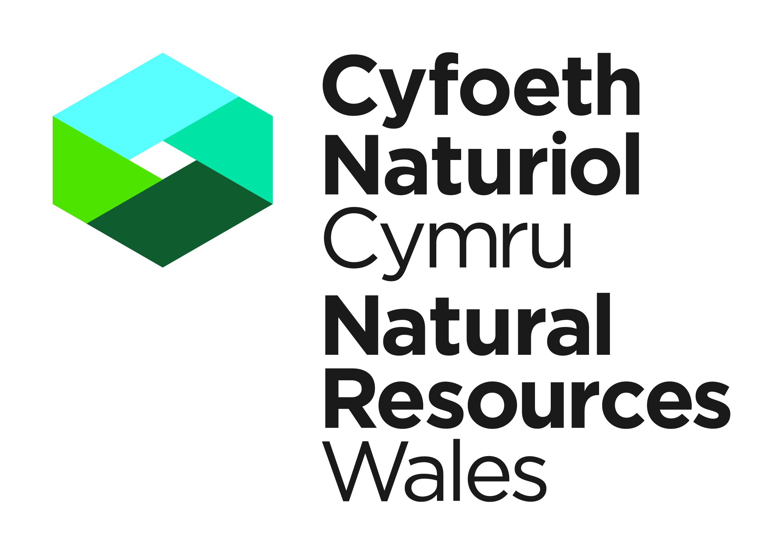


Information for completing an application form

If the document is being handwritten please complete in BLOCK CAPITALS

Please answer ALL questions in detail. Incomplete answers will mean delays in your application
being processed.

Applications can be accepted either electronically or by post (electronic is our preferred option).

Electronic Applications

E-mail Applications to: specieslicence@naturalresourceswales.gov.uk. Please DO NOT also send the application by post. When sending in electronic applications, please ensure that all documents are clearly named.

Postal Applications

The application form must be originally signed by both the licensee and the Ecologist (wet signatures required). Please post to: Species Permitting Team, Natural Resources Wales, Maes y Ffynnon, Penrhosgarnedd, Bangor, Gwynedd, LL57 2DW

This application must be supported by a Method Statement. The Method Statement must include contingency plans if any species are found on-site whilst works is underway
An acknowledgment will be sent out on receipt of your application. We will aim to send the acknowledgement within 5 working days.

NRW aims to process applications within 30 working days. The processing clock will start once we have received a full Application with all the associated information that we ask for in this Application. Please use the check list at the end of the form for guidance. If we have further queries whilst we are processing your Application the clock will stop once we have asked the query, and re-start once that query has been satisfied.

All correspondence sent to you from NRW will be via e-mail. If an e-mail address has not been provided, we will contact you in writing through the post. Please note that this may delay your application due to postal delivery times.

APPLICATION FOR A LICENCE TO REMOVE DEER FROM ONE AREA TO ANOTHER OR FOR TAKING DEER ALIVE FOR SCIENTIFIC OR EDUCATIONAL PURPOSES

SECTION 8 (2) DEER ACT 1991

NOTES FOR GUIDANCE
Please read the following notes carefully.

a. | This application form is for removing deer from one area to another or for taking deer alive for scientific or educational purposes. Licences for the above purposes can be granted under Section 8 of the Deer Act 1991. Applicants must be able to demonstrate that they have a suitable amount of expertise to achieve the stated objectives.
b. | A licence will not confer exemption from any rule or legal provision not contained in the Deer Act 1991. Under the firearms regulation Home Office authority must be obtained before using certain weapons. Questions about the administration of drugs should be directed to the Veterinary Medicines Directorate, Woodham Lane, New Haw, Weybridge, Surrey, KT15 3LF.
c. | All questions in this application form must be completed in detail unless otherwise stated: failure to provide adequate information will delay the processing of your application. Any further information you wish to provide should be appended on additional sheets. We aim to determine applications within 30 working days of receipt of all the information requested. We cannot guarantee an earlier response.
d. | It is a condition of any licence issued that a report of the work carried out under licence is submitted within four weeks of the expiry of the licence. The Licence Report Form can be found on our website. Failure to do so may constitute an offence. Information from these reports is required to provide summary information to NRW and others on the number of licences issued the purpose of the licence and which species are covered. None of these summary statistics includes personal information about licensees. The information may also be used for conservation purposes and shared with other organisations.
e. | Please note that we will not process your application until we have received all the requested documentation. Please make sure that if you are sending documents or plans to us in hardcopy that the print on these can be clearly read. All copies must be identical to the original document, and in colour as appropriate.
f | The information provided by you will be processed by Natural Resources Wales under the General Data Protection Regulation. This will enable us to process your application; to monitor compliance with any permit conditions; to process renewals, and to maintain the relevant public register.  We will use the information you provide in connection with the following:  - Consultation with third parties who are relevant and responsible for responding to consultation requests from NRW to enable us to process your application  - Carrying out statistical analysis, research and development on environmental issues  - Providing public register information for enquiries  - Preventing and investigating possible breaches of environmental law and taking any resulting action  Responding to requests for information under the Freedom of Information Act 2000 and the Environmental Information Regulations 2004  Note that the above is not an exhaustive list and NRW may use the data provided in connection with the application in other ways, as considered appropriate  We would also like to send you details about other topics we think may be of interest to you such as NRW news; services relating to environmental matters; asking for your feedback on our service; and more useful information.  If you consent to receiving further information from us, please tick the following box to confirm  Yes, I would like to receive additional information from NRW relating to environmental matters ☒  Please note we may pass the information on to our agents or representatives to carry this out for us  If you have any further queries or concerns, please contact dataprotection@naturalresourceswales.gov.uk. For further information on the processing of your personal details please see our Privacy Notice page

PART A: Personal Details and Experience

This section applies to the person who will be the ‘Lead Licensee’ or ‘company representative’. This must be a named individual; company information is to be provided in 1b. As the ‘Lead Licensee’ or ‘company representative’, you will be responsible for ensuring compliance with the licence and all licence conditions. Please provide your full name, not initials.

1. Proposed Lead Licensee Details

1a. Are you applying as an individual or on behalf of an organisation?

Individual (please complete 1b) ☐ Organisation (please complete 1c) ☐

1b. Individual Personal Details

Title | Forename(s) |  | Surname
Address
Town
County
Postcode
Primary Contact Number
Secondary Contact Number
E-mail address

1c. Organisation Details

Organisation Representative (full name)
Organisation Name
Organisation Address
Town
County
Postcode
E-mail address
Primary Contact Number
Secondary Contact Number
Position within the organisation (Director, CEO, Regional Manager etc…)
Legal Status of Organisation (Limited Company, Local Authority, Charity etc..)
Please tick to confirm you acknowledge that, as company representative, you are the primary contact for queries relating to this application.
PART B: Who will provide the expertise during the licenced work
 | Applicant |  | Other proposed Authorised Persons

2. Proposed Licensed Authorised Person(s) Details

Licensed Authorised Persons can be authorised by the Lead Licensee to undertake licensable activities on their behalf. If you intend to employ a Licensed Authorised Person(s) please provide their details in the tables below.

Forename(s) | Surname | Company  (if applicable) | Address | Email Address | Telephone Number

PART C: Application Details

For 4. What purposes are you applying for a licence. Tick all relevant boxes:

☐ | Removing deer from one area to another
☐ | Science or educational purposes

5. State why it is necessary to carry out the proposed activities.

6. What methods will be employed to meet the above purpose. Tick all relevant boxes:

☐ | Using any missile carrying or containing stupefying drug or any muscle relaxing agent
☐ | Using nets or traps. Specify the type of nets or traps to be used

7. Please specify the species and sex of the deer to be taken. Please place an X in the relevant boxes in the table below:

☐ | Fallow Deer (Dama dama) | ☐ | Both male and female | ☐ | Female only | ☐ | Male only
☐ | Red Deer (Cervus elaphus) | ☐ | Both male and female | ☐ | Female only | ☐ | Male only
☐ | Roe Deer (Capreolus capreolus) | ☐ | Both male and female | ☐ | Female only | ☐ | Male only
☐ | Sika Deer (Cervus nippon) | ☐ | Both male and female | ☐ | Female only | ☐ | Male only
☐ | Chinese Water Deer (Hydropotes inermis) | ☐ | Both male and female | ☐ | Female only | ☐ | Male only
☐ | Muntjac Deer (Muntiacus reevesi) | ☐ | Both male and female | ☐ | Female only | ☐ | Male only

8 Where appropriate give an estimate of the number of animals involved?

9. Location

a. Please specify the counties which are to be included in the licence. If a licence is just required for a specific location please name the area and the relevant county. If the licence is to cover all counties please state ‘All counties.’ If moving deer from one area to another please state which counties the deer are being moved from and to.

b. Please state whether deer are being moved from an enclosed or open area and also if they are being transported to an enclosed or open area.

10. Please specify the time period for which you require a licence:

From: | To:

11. (a) Please give details of methods of transportation to be used where applicable.

(b) Arrangements for supervision during transportation.

Only answer Question 12 if applying for a licence which will include the use of stupefying drugs or muscle-relaxing agents.

12.a. State why other methods (eg use of nets or traps) are considered to be unsuitable for your purpose.

b. Which drugs are to be used.

c. State the dosage of each drug to be used for each species.

d. Are the drugs used safe for human consumption should the deer subsequently enter the food chain?

Yes ☐ | No ☐
e. State the type of weapon and projectile to be used.

f. Will a qualified veterinary surgeon be in attendance while the deer are being taken?

Yes ☐ | No ☐

Any further information you wish to provide in support of your application should be appended on additional sheets. For example, if the work forms part of a scientific project, it will help your application if you provide a description of the aims, methods and timescale. All questions on the application from must be completed in full.
PART D: Declaration

WARNING: Natural Resources Wales (NRW) can modify or revoke a licence at any time but this will not be done without good reasons. A licence is likely to be revoked immediately if it is discovered that false or incorrect information had been provided on this form or any enclosures that resulted in the issue of a licence.

Has anyone named in section 1 or section 2 of this application ever been convicted of a wildlife offence?  A wildlife offence is an offence under the Wildlife and Countryside Act 1981, the Conservation of Habitats and Species Regulations 2017, the Protection of Badgers Act 1992, the Deer Act 1991, the Hunting Act 2004, the Wild Mammals (Protection) Act 1996, the Animal Welfare Act 2006 and the Protection of Animals Act 1911 (all as amended).  You do not have to declare a previous conviction if you are:  (1) a rehabilitated person for the purposes of the Rehabilitation of Offenders Act 1974 and your conviction is treated as spent; or  (2) in respect of such an offence, a court has made an order discharging you absolutely.  If the answer is yes, please provide details below. |  | Yes ☐ | No ☐
☐ | (If applicable) I confirm that any Licensed Authorise Persons listed on this licence are suitably qualified and experienced to undertake the relevant licensed activities.
☐ | (If applicable) I have the permission of all Licensed Authorised Persons listed in section 2 of this application form to provide NRW with their name and details for the purpose of the application
☐ | (If applicable) I give permission for the Licensed Authorised Person(s) named in section 2a of this form to submit the licence application on my behalf
☐ | (If applicable) I give permission for NRW to send any correspondence relating to this application to the Lead Licensee as well as the Licensed Authorised Person(s) named in section 2
☐ | I understand that failure to comply with any conditions included on any licence granted in respect of this application may constitute an offence.
☐ | I declare that the particulars given in this application and accompanying documents are correct to the best of my knowledge and belief, and I apply for a licence in accordance with these particulars.
☐ | If a licence is granted I agree to send to NRW a written report of the licensed activities within four weeks of the expiry of the licence.

Signature: | Date:  Click or tap to enter a date.
For electronic applications please insert an electronic signature above or place an X in the box opposite to confirm agreement with the declarations above. |  | ☐

Name in BLOCK LETTERS:

PART E: Checklist

 | Please return your completed application to the following Natural Resource Wales contact details. We would prefer an electronic submission if this is possible.
 | Species Protection Team,  Natural Resources Wales,  Maes y Ffynnon,  Penrhosgarnedd,  Bangor,  LL57 2DW  E-mail: specieslicence@naturalresourceswales.gov.uk  Tel. 03000653000 | Checklist before submitting your application:
 |  | 1. Completed Application Form | ☐
 |  | 2. Method Statement | ☐
 |  | 3. Specification for Research Project | ☐
 |  | 4. Application form signed and dated | ☐

