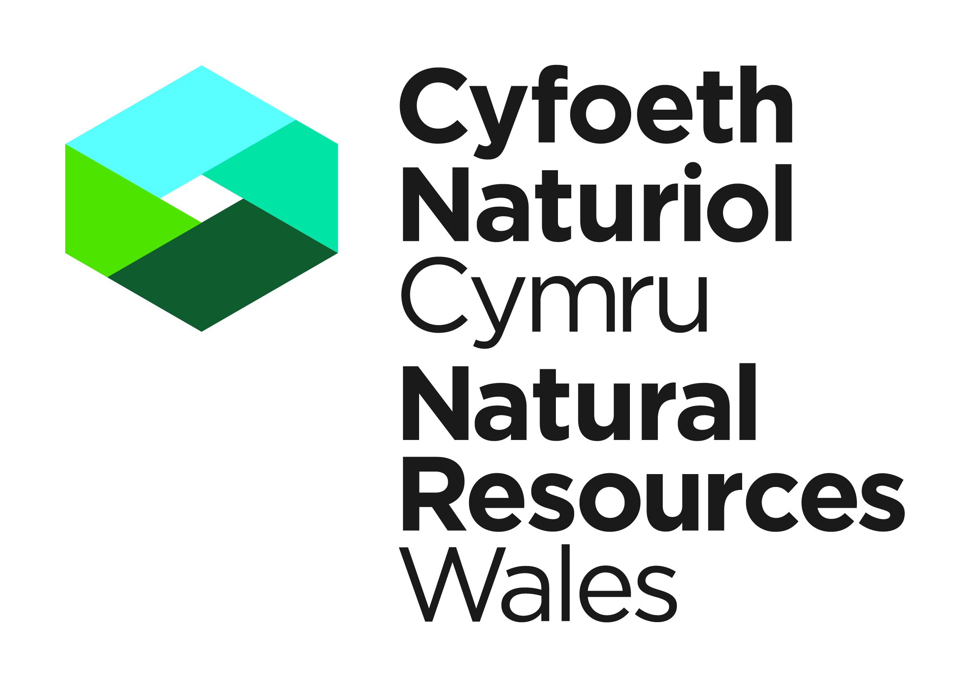


Template Method Statement to be used within an Otter Development Licence Application

This template Method Statement is to be used to form part of your Licence Application for a European Protected Species Development Licence. It will be used to determine the impact of the application on the favourable conservation status of the species concerned (Regulation 55(9) (b) of the Conservation of Habitats and Species Regulations 2017). It must be prepared by a consultant ecologist of other suitably qualified person. You are strongly advised to refer to the following information on otters; “Otters: Guidelines for Developers”, and “Otter Breeding Sites - Conservation and Management (IN129)”. Please submit your Application and supporting Method Statement electronically to the contact details provided below.

Please note as of the 1st March 2018 the declaration box found at the end of this template must be included on any Method Statements submitted in support of a licence application, and must be signed and dated by the applicant and ecologist. Any application containing a Method Statement without this declaration will be rejected.

Contact Details

Natural Resources Wales
Species Permitting Team
Maes Y Ffynnon
Penrhosgarnedd
Bangor
LL57 2DW

03000 654974 / 03000 654921
specieslicence@naturalresourceswales.gov.uk
trwyddedrhywogaeth@cyfoethnaturiolcymru.gov.uk

Method Statement Title:

Method Statement Version Number:

Method Statement Issue Date:
Site Address:

Background and Supporting Information
A Executive Summary.
No more than one side of A4

B Introduction
B.1 Background to activity/development
Include a brief summary of what the proposed activity is and why it is necessary.
B.2 Full details of proposed works on site that are to be covered by the licence
Please ensure sufficent detail is provided on the proposed works e.g. construction of buildings, roads, fences etc. Include current status of planning permission or other consents (if applicable) and any outstanding conditions/reserved matters. Include timescales and order of work.
B.3 Actions requiring licensing
E.g disturb, damage or destroy breeding site or resting place,Briefly explain why these actions are necessary.

C Survey and site assessment
C.1 Existing information on the otters at the survey site.
Provide records from local environmental records centres, local mammal groups, and previous survey work by the applicant or others. Include records from within 5km.
C.2 Statutory sites notified for the species (SSSIs or SACs) within 10km or within the same catchment
C.3 Objectives of any specific survey.
E.g. to determine presence/absence of otters, otter usage of site (e.g. breeding site, resting place, feeding).
C.4 Scaled plan/map of survey area
This should be of appropriate scale and orientation with integral or separate location map at 1:50,000 or 1:25,000 scale and aerial photographs.
C.5 Site/habitat description (relevant to otters)
Include annotated photographs if applicable.
C.6 Field survey(s).
Include survey method, timings (day/evening), weather conditions (wind, rain, temperature – tabulated for multiple survey visits), personnel involved (provide individual licence numbers, if held) and details of experience/competence in this type of work, and equipment used. Also include any constraints and justifications for departures from best practice.
C.7 Survey Results.
Summarise findings in table form (if appropriate); provide clear, annotated, and cross-referenced maps/plans/photographs. Raw data to be appended.
C.8 Interpretation/evaluation of survey results.

D Impact assessment - potential impacts of proposed works in absence of mitigation/compensation.
D.1 Short-term impacts: disturbance
E.g. noise, overnight lighting, temporary disruption to water courses
D.2 Long-term impacts: habitat modification.
Note that impacts can be positive or negative as this is in absence of mitigation.
D.3 Long-term impacts: habitat loss.
Impact on populations to be taken into account at local, regional, and national level. Loss of habitat cover, loss of water features.
D.4 Long-term impacts: fragmentation and isolation.
E.g. Changes to water courses and water bodies, undisturbed areas of cover.
D.5 Post-development interference impacts.
E.g. disturbance.
D.6 Predicted scale of impact
Include impacts on the species status at the site, local county and regional levels.

Delivery Information – Mitigation, compensation and monitoring
Description of how the impacts will be addressed in order to ensure no detriment to the maintenance of the population at a favourable conservation status.
E Works to be undertaken
Please identify which works will be undertaken or supervised by a licensed ecologist .
E.1 Capture (if applicable).
Timings, effort, methods to be employed, care of otters, release sites etc. Include diagrams to show capture/exclusion apparatus if non-standard techniques are proposed.

E.2 Otter habitat
E.2.1 In-situ retention of habitat
E.2.2 Modification of existing habitat.
E.2.3 New habitat creation
E.2.4 Scaled maps/plans
To show proposals/mitigation outlined above in relation to existing and proposed habitat features and in relation to the proposed development outline. A GIS data layer may be included with your application to illustrate locations of habitats in E.2.1 to E.2.3.

E.3 Mechanisms for ensuring delivery of mitigation and compensation measures

Include measures to ensure compliance with this method statement
E.4 Mitigation contingencies
Describe any contingency proposals including circumstances when the contingencies will be instigated.

E.5 Biosecurity risk assessment
Consider presence of non-native species and disease on site and actions to be undertaken that will prevent their spread onto or off the site

F Post-development site safeguard
F.1 Habitat/site management and maintenance
Include ongoing land management proposals, details of who will be responsible for management and maintenance, on going running costs, site/structure ownership and monitoring development of new habitats.
F.2 Population monitoring, habitat usage etc.
Include details of monitoring effort, timing, personnel involved and equipment to be used.
F.3 Post-development mitigation contingencies
Describe the action that you will take if monitoring results are unfavourable.
F.4 Mechanism for ensuring delivery of post-development works
As appropriate e.g. Section 106 Agreement, to include details of who will undertake the work and reporting details, other covenants, contractual agreements or wardening schemes.

G Timetable of works.
Include timings of habitat clearance and development activities, mitigation measures, monitoring and other post development works.

H Land Ownership – Mitigation Site/Compensation Site
H.1 Mitigation Site/Compensation Site Ownership
If mitigation is to be undertaken at a location not owned by the applicant, you must provide the written consent of the relevant land owner(s). You must also provide details of how the mitigation is to be maintained in the long term (e.g. a legal agreement).
H.2 Mitigation Site/Compensation Ownership post construction
If the ownership of the mitigation site will change after construction please confirm the identity of the prospective owners/occupiers together with timescales associated with transfer of occupancy or other form of legal interest. You must also provide details of how the mitigation is to be maintained in the long term (e.g. a legal agreement).

I Declaration

I declare that should a licence be granted, the work as proposed in this Method Statement will be strictly adhered to. I understand that any deviation from the works as proposed in this Method Statement without agreement from NRW would result in a breach of the licence.

NB. Applicants should note that it is an offence under regulation 59 of the Conservation of Habitats and Species Regulations 2017 to knowingly or recklessly provide false information in order to obtain a licence.

Signature of the Applicant |  | Date
For electronic submissions please insert an electronic signature above or place an x in the box opposite to confirm agreement with the declarations above. |  |  | ☐
Full name in BLOCK LETTERS
Signature of the Ecologist |  | Date
For electronic submissions please insert an electronic signature above or place an x in the box opposite to confirm agreement with the declarations above. |  |  | ☐
Full name in BLOCK LETTERS
J References
Credits for source information.
K Annexes
K.1 Pre-existing survey reports
K.2 Raw survey data

CCW publication – available to download from the NRW website
Liles G (2003). Otter Breeding Sites. Conservation and Management. Conserving Natura 2000 Rivers Conservation Techniques Series No. 5. English Nature, Peterborough. Available to downland from the Natural England website.

