26th January 2017

Paper Title: | Dee Conservancy Update (Navigation)
Paper Reference: | NRW B B 8.17
Paper Sponsored By: | Tim Jones
Paper Presented By: | Nick Thomas/Dawn Beech

Purpose of Paper: | For information
Recommendations: | No recommendations, for information only

Impact: To note – all headings might not be applicable to the topic | Looking at the long term: Future Regulation of the Dee Conservancy

Backgound

1. The Dee Conservancy is the formal name given to the harbour area for which NRW is the conservancy, harbour, and local lighthouse authority. This area consists of the tidal Dee and extends from Wilcox Point, downstream of the Chester weir, seawards to an imaginary line from the Point of Ayr on the Welsh coast to Hilbre Point on the Wirral peninsular.

2. As the Statutory Harbour Authority for the Dee estuary, we are responsible for managing and running a safe and efficient harbour. We have particular responsibilities in relation to:

- Undertake and regulate marine operations in a way that safeguards the Dee Conservancy, its users, the public and the environment to achieve the standard of marine safety required by the Port Marine Safety Code

- Promote the use of the Dee Conservancy and ensure that its economic development takes into account and balances the views and needs of all stakeholders with the use of natural resources and conservation of the environment.

3. The approaches to the Port of Mostyn (PoM) from the sea are heavily used by small vessels servicing the offshore windfarms, fishing and sailing boats, and less regularly by cargo ships. Upstream of Mostyn there is less traffic but it is regularly used by fishing boats, especially in relation to cockling and the Dee River Craft (DRC) which carries Airbus 380 wings from Broughton to PoM a few times a month. This year the Connah’s Quay Watermans Association began operating an occasional commercial passenger vessel service, catering for up to 10 members of the public at a time, which is licenced by us.

Risk Management

4. Strong tidal currents mean that sand banks and channels shift regularly and make navigation within the Estuary potentially hazardous. Floating and semi-submerged debris may be present, particularly in the canalised section between Chester and Connah’s Quay, where it is carried up and down on the tide. To address these hazards NRW has put in place a comprehensive safety system (see Annex 1) that includes:
- Contracted-in staff to manage Navigation (a harbour master and marine contractor, on call 24 hours a day)
- A system of buoys and lights to identify the channel and hazards
- A risk management system that involves weekly checks of navigational aids and removal of debris in the river
- Marine pollution plans and periodic exercises
- Regular liaison with the Port of Mostyn
- Communication with users of the tidal Dee

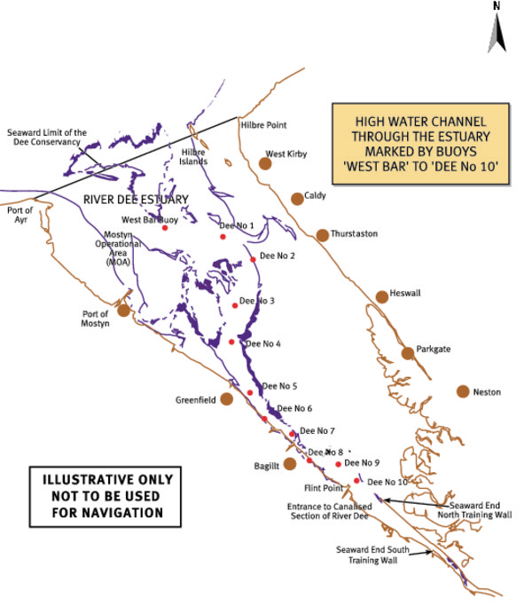

5. The Dee Conservancy Estate includes some land around the Estuary which confers significant liabilities on NRW, most notably part of the beach car park at Talacre, near the Point of Ayr, land at Saltney and Crane Wharf in Chester.

Recent Incidents/Issues

6. There have been a number of significant incidents over the last few years:

- Port of Mostyn. Wholly contained within the Conservancy limits is the Port of Mostyn within which the majority of commercial operations take place. Incidents occurring within the Mostyn statutory harbour area can quickly impact upon the Conservancy. In January 2013 the large RoRo vessel Ciudad de Cadiz broke free from its mooring in the port and was subsequently grounded in the Conservancy for around a week before being re-floated. Also contained within the Mostyn statutory harbour are pontoon berths for wind farm service vessels. Part of the setup includes refuelling facilities and despite complex monitoring and control systems, there have previously been some small spills associated with refuelling operations. Strong tidal flows inevitably mean that a major spill incident will impact on the Conservancy with hydrocarbons carried away from the immediate pontoon area.

- During the 2013-14 winter storms, the North Training Wall (downstream of Connah’s Quay) was partially breached by the tidal surge. The wall keeps the main river channel to the Welsh side of the estuary. A complete breach would have a major impact on the navigation channel. Estimated repair cost is in excess of £40,000 (2014). To date some small scale work has taken place on the wall, to ensure it is stabilised and maintains the channel on the Welsh side of the estuary.

- Jetties in the Queensferry Area – these old wooden jetties are deteriorating. Eventually they will collapse, potentially resulting in large timber baulks floating around the river, posing a major threat to navigation. We believe Tata Steel may own some of the jetties but have been unable to prove this as yet. If the Harbour Revision Order (see below) is granted, we will be able to compel the owners to make the jetties safe

- Part of the beach car park at Talacre is owned by ENI (the Oil and gas company that currently operates the Rig in Liverpool Bay) and part by NRW. This floods on high tides, resulting in the gate controlling access to the car park having to be shut. When this happens on warm summer weekends, it can result in traffic chaos in Talacre, due to limited alternative parking. We are working with various stakeholders to try to address this problem. In May the gate to the ENI part of the car park was accidently left open on a high tide resulting in approximately 40 cars being flooded, some of which were written off.

- Crane Wharf in Chester. Up to the Nineteenth Century Chester was one of the more important ports in western Britain. However, there is currently no access to the tidal river in Chester at all and so there are proposals to create a slipway or pontoon type access to the river, partly for emergency service access and partly for commercial craft.

Harbour Revision Order

7. Environment Agency Wales applied for a Dee Harbour Revision Order (DHRO) in January 2005, with a Public Inquiry in November 2005. If made the DHRO would give NRW powers to:
- further implement the Port Marine Safety Code including bye laws and general directions
- modernise NRW’s conservancy functions
- enable ship dues to be collected.

8. The Secretary of State for Transport has indicated that EAW (now NRW) will be granted the DHRO, and it seemed likely that these powers would be transferred in 2016. However a legal issue regarding the legality of a Welsh Assembly Sponsored Body to take on these powers has been identified and is currently being re- examined by Department of Transport and Welsh Government lawyers.

Financial Implications - Costs and Responsibilities

9. The Dee Conservancy work is managed by the Dee Estuary Navigation Officer, with an annual budget of approximately £170,000, primarily to cover the cost of the Harbour Master and Marine Contractor and to purchase equipment such as replacement buoys and lights. We receive a limited income from Airbus and Eirgrid with regards to annual easements.

10. The Duty Holder for the Dee Conservancy is Tim Jones. Dawn Beech, NRW’s Dee Navigation Officer manages work on the Dee Conservancy, and following a recent change Chris Jones has been appointed as the Designated Person, providing independent assurance about the operation of our safety management system.

11. Karen Balmer has agreed to be Board Champion for the Dee Conservancy work.

12. A review of delivery across NRW’s marine remit has been undertaken alongside the Business Area Reviews. The future delivery of NRW's responsibilities in respect of the Dee Conservancy will be one of the aspects considered as part of the organisational design work and delivery of the Marine Review recommendations

Recommendations - Conclusion

13. NRW’s inheritance of the Dee Conservancy places significant risks and liabilities on the organisation. Whilst the overall governance of marine responsibilities in NRW is subject to review, within this for the Dee Conservancy there is a comprehensive management system in place that reduces risk. The granting of the Harbour Revision Order will give NRW modern and increased powers to manage navigation in the Estuary and to re-coup costs.

